**How to install Elastic search and Kibana in RHEL:**

**Pre-Requisite for installing:**

* **Java – OpenJDK**

**Step1: Yum install wget java-11-openjdk-devel -y**

**Below commands to install Elastic search:**

**Step2: Go to the below website:**

[**https://www.elastic.co/downloads/elasticsearch**](https://www.elastic.co/downloads/elasticsearch)

**step3: Choose platform as rpm x86_64 and copy link address.**

**Step4: Go to the your linux machine paste the copy command like below with wget command.**

**Wget** [**https://artifacts.elastic.co/downloads/elasticsearch/elasticsearch-8.7.1-x86_64.rpm**](https://artifacts.elastic.co/downloads/elasticsearch/elasticsearch-8.7.1-x86_64.rpm)

**Step5: Install the above file with rpm command.**

**Rpm -I elasticsearch-8.7.1-x86_64.rpm.**

**Step6: execute below commands one by one.**

**systemctl daemon-reload**

**systemctl enable elasticsearch.service**

**systemctl start elasticsearch.service.**

**Step7: Go to the etc directory in etc go to the elastic search directory and edit elasticsearch.yml file by using below command.**

**Cd /etc/elasticsearch**

**Vi elasticsearch.yml**

**Step8: edit the file as per below image.**

**In network.host : Add your private ip.**

**In discovery.seed_hosts : un comment the file and remove inside information and add your private ip in between the boxes.**

**xpack.security.enabled: Here It will be true by default make it false.**

**cluster.initial_master_nodes: Here by default there will be something change it to what ever the name beside node.name : node-1**

**Save and exit**

**Systemctl restart elasticsearch.service**

**And Access your elastic search with below command**

* **Public-ip:9200**

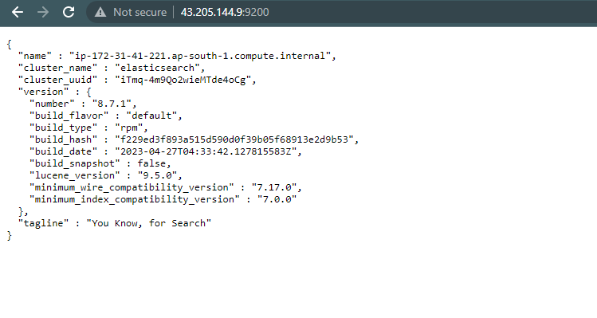

**Below commands to install Kibana:**

**Step1: Go to the below website**

[**https://www.elastic.co/downloads/kibana**](https://www.elastic.co/downloads/kibana)

**Step2: Choose platform as rpm x86_64 and copy link address**

**Step3: Go to the your linux machine paste the copy command like below with wget command.**

**Wget** [**https://artifacts.elastic.co/downloads/kibana/kibana-8.7.1-x86_64.rpm**](https://artifacts.elastic.co/downloads/kibana/kibana-8.7.1-x86_64.rpm)

**Step4: Install the above file with rpm command.**

**Rpm -I kibana-8.7.1-x86_64.rpm**

**Step5: execute below commands one by one.**

**systemctl daemon-reload**

**systemctl enable kibana.service**

**systemctl start kibana.service.**

**Step6: Go to the etc directory in etc go to the kibana directory and edit kibana.yml file by using below command.**

**Cd /etc/ kibana**

**Vi kibana.yml**

**Step7: edit the file as per below image.**

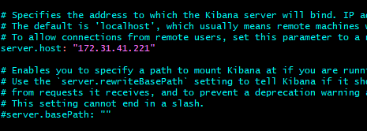

**Near server.host : paste your private IP address.**



**Here paste your private IP address in the place of ip number.**

**Save and exit.**

**systemctl restart kibana.service.**

**Access your kibana with below command :**

* **Public-ip:5601**

